**ASSIGNMENT 01**

**COMSATS University Islamabad**

Sahiwal Campus



***Usama Sarwar***

FA17-BS(CS)-090-B

***Ms. Raheela***

Pattern Recognition

October 17, 2020

Table of Contents

1. Implementation of Simple Artificial Neural Network 1

1.1 Code: 1

1.2 Output 2

2. Implementation of Artificial Neural Network for AND Logic Gate with 2-bit Binary Input 3

2.1 Approach: 3

3. Python Code 4

4. Output 6

# Implementation of Simple Artificial Neural Network

Neural networks are artificial systems that were inspired by biological neural networks. These systems learn to perform tasks by being exposed to various datasets and examples without any task-specific rules. The idea is that the system generates identifying characteristics from the data they have been passed without being programmed with a pre-programmed understanding of these datasets. Neural networks are based on computational models for threshold logic. Threshold logic is a combination of algorithms and mathematics. Neural networks are based either on the study of the brain or on the application of neural networks to artificial intelligence. The work has led to improvements in finite automata theory.

## Code:

import numpy as np

# array of any amount of numbers. n = m

X = np.array([[1, 2, 3],

              [3, 4, 1],

              [2, 5, 3]])

# multiplication

y = np.array([[.5, .3, .2]])

# transpose of y

y = y.T

# sigma value

sigm = 2

# find the delta

delt = np.random.random((3, 3)) - 1

for j in range(100):

    # find matrix 1. 100 layers.

    m1 = (y - (1/(1 + np.exp(-(np.dot((1/(1 + np.exp(

                   -(np.dot(X, sigm))))), delt))))))*((1/(

                       1 + np.exp(-(np.dot((1/(1 + np.exp(

                   -(np.dot(X, sigm))))), delt)))))*(1-(1/(

                       1 + np.exp(-(np.dot((1/(1 + np.exp(

                   -(np.dot(X, sigm))))), delt)))))))

    # find matrix 2

    m2 = m1.dot(delt.T) * ((1/(1 + np.exp(-(np.dot(X, sigm)))))

                    * (1-(1/(1 + np.exp(-(np.dot(X, sigm)))))))

    # find delta

    delt = delt + (1/(1 + np.exp(-(np.dot(X, sigm))))).T.dot(m1)

    # find sigma

    sigm = sigm + (X.T.dot(m2))

# print output from the matrix

print(1/(1 + np.exp(-(np.dot(X, sigm)))))

## Output

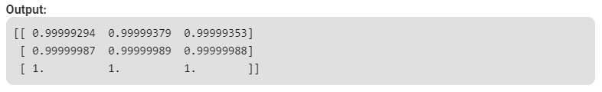

# Implementation of Artificial Neural Network for AND Logic Gate with 2-bit Binary Input

Artificial Neural Network (ANN) is a computational model dependent on the biological neural networks of animal cerebrums. ANN is modeled with three kinds of layers: an information layer, concealed layers (at least one), and a yield layer. Each layer contains hubs (like biological neurons) are called Artificial Neurons. All hubs are associated with weighted edges (like neural connections in biological minds) between two layers. Initially, with the forward engendering capacity, the yield is anticipated. At that point through backpropagation, the weight and predisposition to the hubs are refreshed to limiting the blunder in forecast to accomplish the intermingling of cost work in deciding the final yield. AND logical function truth table for 2-bit binary variables i.e., the input vector ***x: (x1, x2)*** and the corresponding output ***y-***

|  |  |  |
| --- | --- | --- |
| *x1* | *x2* | *y* |
| 0 | 0 | 0 |
| 0 | 1 | 0 |
| 1 | 0 | 0 |
| 1 | 1 | 1 |

## Approach:

Step1: Import the required Python libraries

Step2: Define Activation Function: Sigmoid Function

Step3: Initialize neural network parameters (weights, bias)

and define model hyperparameters (number of iterations, learning rate)

Step4: Forward Propagation

Step5: Backward Propagation

Step6: Update weight and bias parameters

Step7: Train the learning model

Step8: Plot Loss value vs Epoch

Step9: Test the model performance

# Python Code

# import Python Libraries

import numpy as np

from matplotlib import pyplot as plt

# Sigmoid Function

def sigmoid(z):

    return 1 / (1 + np.exp(-z))

# Initialization of the neural network parameters

# Initialized all the weights in the range of between 0 and 1

# Bias values are initialized to 0

def initializeParameters(inputFeatures, neuronsInHiddenLayers, outputFeatures):

    W1 = np.random.randn(neuronsInHiddenLayers, inputFeatures)

    W2 = np.random.randn(outputFeatures, neuronsInHiddenLayers)

    b1 = np.zeros((neuronsInHiddenLayers, 1))

    b2 = np.zeros((outputFeatures, 1))

    parameters = {"W1" : W1, "b1": b1,

                  "W2" : W2, "b2": b2}

    return parameters

# Forward Propagation

def forwardPropagation(X, Y, parameters):

    m = X.shape[1]

    W1 = parameters["W1"]

    W2 = parameters["W2"]

    b1 = parameters["b1"]

    b2 = parameters["b2"]

    Z1 = np.dot(W1, X) + b1

    A1 = sigmoid(Z1)

    Z2 = np.dot(W2, A1) + b2

    A2 = sigmoid(Z2)

    cache = (Z1, A1, W1, b1, Z2, A2, W2, b2)

    logprobs = np.multiply(np.log(A2), Y) + np.multiply(np.log(1 - A2), (1 - Y))

    cost = -np.sum(logprobs) / m

    return cost, cache, A2

# Backward Propagation

def backwardPropagation(X, Y, cache):

    m = X.shape[1]

    (Z1, A1, W1, b1, Z2, A2, W2, b2) = cache

    dZ2 = A2 - Y

    dW2 = np.dot(dZ2, A1.T) / m

    db2 = np.sum(dZ2, axis = 1, keepdims = True)

    dA1 = np.dot(W2.T, dZ2)

    dZ1 = np.multiply(dA1, A1 * (1- A1))

    dW1 = np.dot(dZ1, X.T) / m

    db1 = np.sum(dZ1, axis = 1, keepdims = True) / m

    gradients = {"dZ2": dZ2, "dW2": dW2, "db2": db2,

                 "dZ1": dZ1, "dW1": dW1, "db1": db1}

    return gradients

# Updating the weights based on the negative gradients

def updateParameters(parameters, gradients, learningRate):

    parameters["W1"] = parameters["W1"] - learningRate * gradients["dW1"]

    parameters["W2"] = parameters["W2"] - learningRate * gradients["dW2"]

    parameters["b1"] = parameters["b1"] - learningRate * gradients["db1"]

    parameters["b2"] = parameters["b2"] - learningRate * gradients["db2"]

    return parameters

# Model to learn the AND truth table

X = np.array([[0, 0, 1, 1], [0, 1, 0, 1]]) # AND input

Y = np.array([[0, 0, 0, 1]]) # AND output

# Define model parameters

neuronsInHiddenLayers = 2 # number of hidden layer neurons (2)

inputFeatures = X.shape[0] # number of input features (2)

outputFeatures = Y.shape[0] # number of output features (1)

parameters = initializeParameters(inputFeatures, neuronsInHiddenLayers, outputFeatures)

epoch = 100000

learningRate = 0.01

losses = np.zeros((epoch, 1))

for i in range(epoch):

    losses[i, 0], cache, A2 = forwardPropagation(X, Y, parameters)

    gradients = backwardPropagation(X, Y, cache)

    parameters = updateParameters(parameters, gradients, learningRate)

# Evaluating the performance

plt.figure()

plt.plot(losses)

plt.xlabel("EPOCHS")

plt.ylabel("Loss value")

plt.show()

# Testing

X = np.array([[1, 1, 0, 0], [0, 1, 0, 1]]) # AND input

cost, _, A2 = forwardPropagation(X, Y, parameters)

prediction = (A2 > 0.5) * 1.0

# print(A2)

print(prediction)

# Output

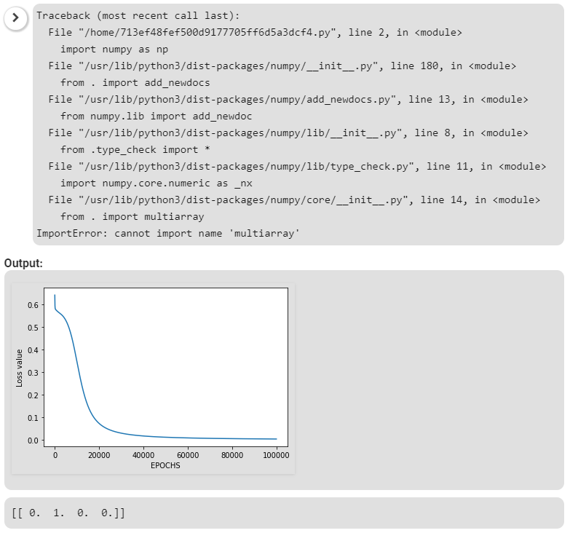

Here, the model predicted output for each of the test inputs are exactly matched with the AND logic gate conventional output (***y***) according to the truth table and the cost function is also continuously converging. Hence, it signifies that the Artificial Neural Network for the AND logic gate is correctly implemented.